**SRINIVASA INSTITUTE OF ENGINEERING** AND TECHNOLOGY

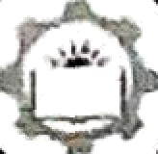

(UGC- Autonomous)

(Approved by AICTE, Permanently affiliated to JNTUK, Kakinada, ISO 9001 : 20 l5 certified Institution) ( A ccred ited by NAAC w it li 'A' G r ride ; Recognise d by UG C u nder sect ions 2( f) & 12( B) )

NH-216, Ainalapuram-KakinadaHighway, Cheyyeru (V), AMALAPURAM-533216, E.G.Dt.

# Date: 06.10.2023

To

The Manager - HR,

Miracle Sofiware systems (1) Ltd, Visakhapatnam.

Sir,

Subject: - Industrial Visit - IV yi. B.Tech Computer Science Engineerin students —

Request to accord permission - Reg.

Srinivasa Institute of Engineering and Technology (Autonomous) was established in the year 2009 by Sri Sacaswathi Edilcational Society. The splendid avenue, imposing buildings and sprawling play grounds and is located in the heart of Konaseema, near Amalapuram and has become one of the most preferred choice of the aspirants who want to pursue quality engineering education. The Institute achieved accolades with impressive credentials, and stands as an epitome towards Quality education in Polytechnic, B.Tech., and M.Tech. programmes.

As a pañ of curricular activities we encourage our students to visit various industries to experience the Industrial, Research & Development and Production environment. 1 request you to grant the permission for 120 students (B.Tech IV yr., Computer Science Engineering) and 4 faculty members to visit your organisation on any convenient day between 09-10-2023 to 17-10- 2023.It is further informed that the students Will be sent as batches(60 students) on different days in the above period.Kindly provide two slots for two batches.

**Yours sincerely,**

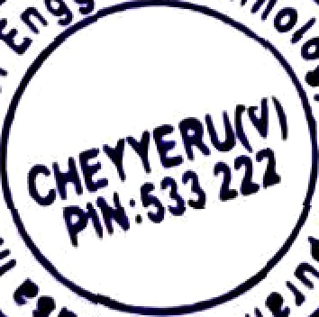



# Principal

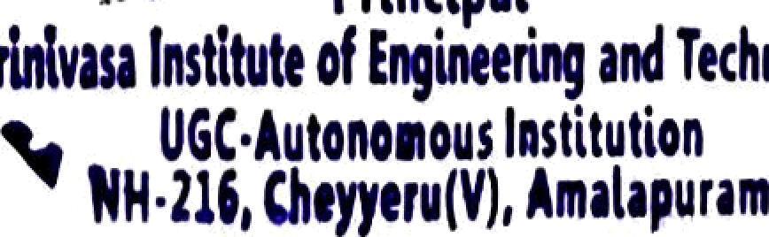

**Website:**[**www.Sriniet.edu.in**](http://www.Sriniet.edu.in/)E-Mail: infofisriniet.edu.in

Phone No:7569171667